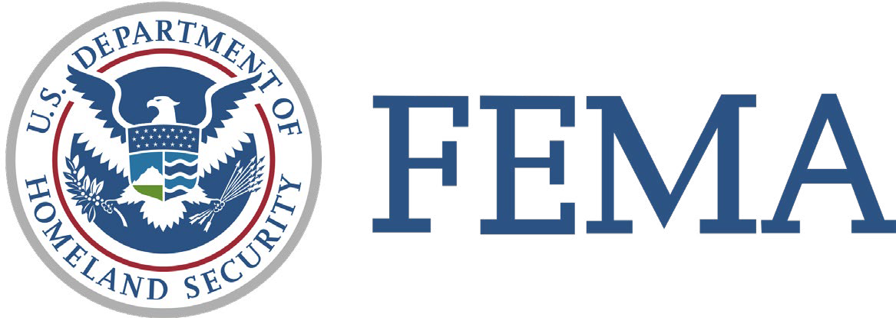

FEMA CIVIL RIGHTS NOTICE FOR MEMBERS OF THE PUBLIC

FEMA may provide or fund programs to support the public before, during, and after a disaster. These programs must comply with Federal civil rights laws and nondiscrimination requirements in the Stafford Act.
FEMA does not treat people differently because of race, color, national origin, sex, sexual orientation, religion, age, disability, English proficiency, or economic status.
FEMA provides free aids and services to people to help them communicate with us and understand FEMA programs:
- Information available in Braille, large print, or audio
- Information available in accessible electronic formats on FEMA’s website
- Qualified sign language interpreters
- Qualified multilingual interpreters
- Information written in other languages
If you need assistance to access a FEMA program or service or a program or service funded by FEMA, please contact FEMA at 800-621-3362 (TTY: 800-462-7585), Colden D. Mitchell at 202-531-3239; colden.mitchell@Fema.dhs.gov or FEMA-CivilRightsOffice@fema.dhs.gov.

If you have a complaint, you must report it within 180 days of the alleged discriminatory act. To report a concern or complaint of discrimination, please
- call FEMA at 202-212-3535 and press 1 for Civil Rights
- send an email to FEMA-CivilRightsOffice@fema.dhs.gov ;or
- send a letter explaining the issue to:

FEMA OFFICE OF EQUAL RIGHTS
Civil Rights Section
500 C Street, SW
Room 4SW-0915
Washington, DC 20472
For questions about disaster assistance, please call FEMA's Helpline at 800-621-3362 (TTY: 800-462-7585). FEMA’s Helpline is available to all disaster survivors, including those whose primary language is not English. Press 2 for Spanish or stay on the line for more language options.

