May 5, 2020
#GivingTuesdayNow
Global Action for Giving and Unity in Response to COVID-19

#GivingTuesdayNowNM

Ideas for Nonprofits and Grantmakers

Ideas for Nonprofits

- Solicit matching grants.
  - Many donors work at companies that will match donations made by their employees. Encourage your donors to submit matching gift requests.
  - Ask your board to support a matching gift to incentivize new or larger donations.
- Solicit a local business.
  - Some ideas for how a business can give back:
    - Donate a percentage of proceeds from the day's sales.
    - Donate proceeds from the sales of a particular item.
    - Host your organization on #GivingTuesdayNow for a fundraising event.
    - Their staff can do a volunteer project with your organization.
    - Their staff can collectively contribute to your organization.
- Make sure your constituents know your nonprofit is part of this movement.
  - Use social media to leverage your #GivingTuesdayNow campaign. Use the hashtag often on Twitter, Facebook and Instagram.
- Consider mobile or online giving.
  - #GivingTuesdayNow is a great day to engage your online community and transform followers and fans into donors.
- Organize a volunteer project for your organization.
  - Invite donors, employees and your neighbors to get together to celebrate giving by creating a day of service.
  - Obtain skilled volunteers through New Mexico Volunteer Connection.
- Share your story!
  - While #GivingTuesdayNow is doing press for the entire coalition, consider reaching out to media outlets to spread the word about your nonprofit.
  - Remember, we are leveraging the power of collaboration, so be sure to say that your nonprofit is part of the statewide coalition #GivingTuesdayNow!

Ideas for Grantmakers

Why Support #GivingTuesdayNow?
- To assist grantees in gaining more support
- To leverage opportunities to partner with grantees
- To collaborate with other funders and community partners
- Grantmakers have the power to speak with volume in the community; use your voice to promote philanthropy!

Ways for Grantmakers to Participate in #GivingTuesdayNow

- Sign up to stay informed about #GivingTuesdayNow at www.GivingTuesday.org.
- Share information about #GivingTuesdayNow with your grantees.
- Encourage staff and trustees to participate in #GivingTuesdayNow.
- Share information about #GivingTuesdayNow with your local New Mexico community. Include information on your website, newsletter and social media.
- Encourage your grantees to participate in the coalition; share resources and ideas with them for running a great campaign.
- Announce surprise grants to existing or new grantees.
- Provide matching funds to grantees that raise money from sources outside of your grantmaking entity.
- Provide challenge grants to grantees for achieving particular strategic goals, like new or recurring donors.
- Provide monetary support for marketing efforts of the overall #GivingTuesdayNow coalition campaign.
- Community Foundations can plan a campaign to encourage new donations to donor-advised funds.
- Corporate funders should consider an employee volunteering day in addition to potential monetary giving and/or an employee matching campaign.
- Work with grantmaking partners to provide a community matching fund for #GivingTuesdayNow coalition participants.
- Share information about your efforts via a press release, your website and social media.

#GivingTuesdayNow

Social Media Tips

Social Media Tips

- Schedule it!
  - Schedule your giving reminders across all platforms using tools like HooteSuite and your Facebook scheduler. Try to analyze peak times when your followers are most active.
  - Have super supporters post on social media on December 3rd saying that they gave to your organization on #GivingTuesdayNow.
- First Tuesday giving.
  - Offer an option for donors to repeat their donations on the first Tuesday of every month.
- Be a part of the social media conversation.
  - Be hyperactive on social media throughout the day and into the evening.
- Prepare a landing page.
  - Promote your #GivingTuesdayNow campaign on your website’s homepage and across subpages so that all visitors will know about it.
  - Create a focused giving page just for #GivingTuesdayNow and promote that exact page. Don’t make people have to dig to find your donate button!
- Say thanks!
  - Use social to be social — say thank you to your donors.
- Make donations tangible.
  - Will the money go toward a new program or needed equipment? Giving transparency can help get “fence-sitters” to convert if they’re compelled by your story.
- Don’t stress about graphics.
  - Don’t have a designer? Don’t stress. Your visual #GivingTuesdayNow posts don’t need to be professionally produced. In fact, the most popular images you post on #GivingTuesdayNow could be quick cellphone shots. However, a great tool for creating professional-looking images is www.canva.com.
  - A few ideas of great visuals that will carry your message far:
    - Behind-the-scenes photos of staff getting ready for #GivingTuesdayNow
    - Photos or video from an in-person event you hold on the day
    - A video collage of your supporters talking about why they give
- Post on social media often, and have fun with it!
- Don’t forget to use the hashtag so we can find you!

Past #GivingTuesday
Social Media Examples
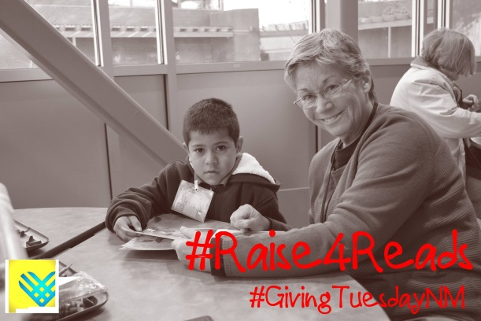 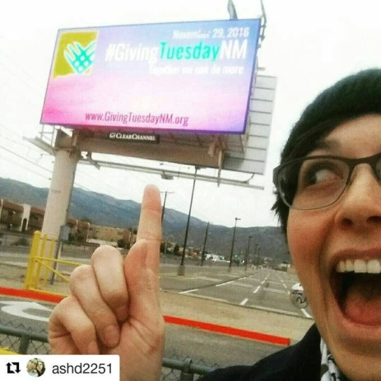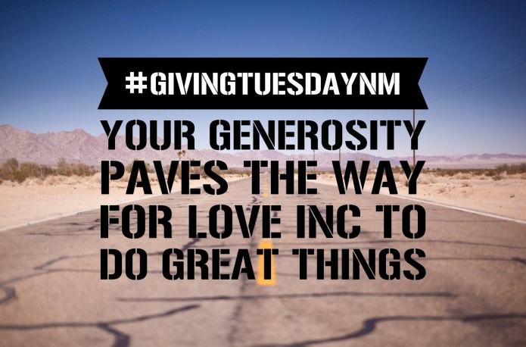 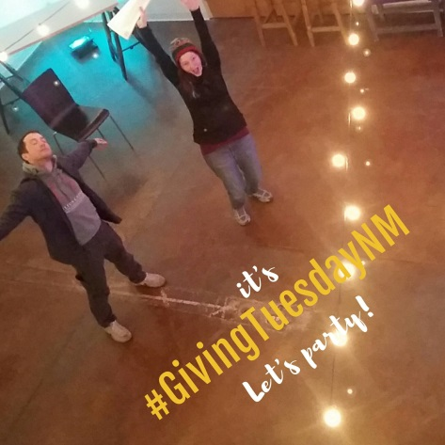
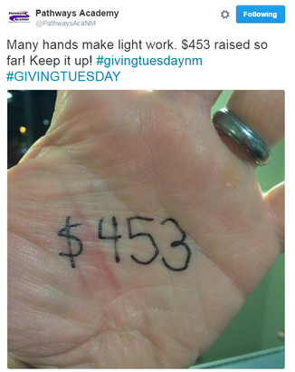 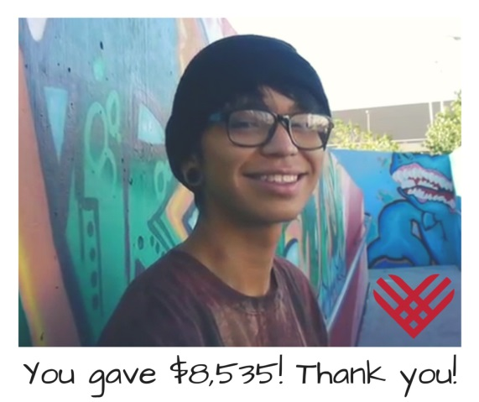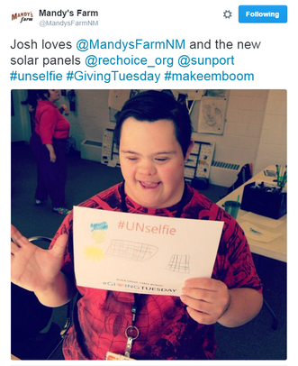

#GivingTuesdayNow

Email Tips

Email Tips
- Set your organization apart.
  - Don’t send templates verbatim — they should serve as a guide, not a blueprint.
  - Remember, the funding community in New Mexico is small; if you use a canned message that another organization has used, the funder or donor will know it.
- Plan your email schedule — and always include a call to action!
  - Will you send to all your constituents, donors, newsletter recipients, etc.?
  - Will you send special emails to volunteers, Board members, ambassadors?
- Are you going to send old-fashioned snail mail?
  - Decide who will receive these letters and make sure they are sent well in advance.

Sample Email
Challenge or Matching Grant Request

Dear _________,

We are excited to participate in #GivingTuesdayNow, a global day of giving and unity set to take place on May 5, 2020 as an emergency response to the unprecedented need caused by COVID-19.

I am writing to ask for your help as we are thinking about strategies to leverage donations. Research shows that even a small matching or challenge grant makes a big difference with new, lapsed and younger donors. One of our key goals on #GivingTuesdayNow is to make an impact with acts of generosity to ensure the sustainability of organizations and services that are crucial to the care and support of our communities.

As a generous supporter, you know how important our work is to the community. Will you help us spur additional engagement and attract new supporters with a matching or challenge grant?

I would appreciate an opportunity to share with you our specific #GivingTuesdayNow goals that a matching gift would help us to achieve.

Thank you for being a dedicated supporter. Your giving has a significant impact on our mission to [INSERT PHRASE ABOUT YOUR WORK]. I'll follow up with you to discuss this exciting campaign.

Thank you so much for your commitment to our work!

Sincerely,

[Your Name]
[Your Nonprofit]

Sample Email
Communicating Participation in #GivingTuesdayNow

Dear __________,

On Tuesday, May 5, 2020 we are participating in #GivingTuesdayNow, a global day of giving and unity as an emergency response to the unprecedented need caused by COVID-19.

We are excited to be part of the #GivingTuesdayNow coalition and invite you to join the movement. You can help by letting your friends, family and colleagues that #GivingTuesdayNow is coming and help rally people around the world to tap into the power of human connection and strengthen communities at the grassroots level.

Here are some ideas for helping to spread the word:
- Let local elected officials, partner nonprofits and small businesses know about #GivingTuesdayNow. Encourage them to sign up at www.GivingTuesday.org.
- Use the hashtag #GivingTuesdayNow to talk about the New Mexico nonprofits and causes you care about and support.

The best way to give back to the community in which we live is by coming together to support one another. This can be through dollars, time or other ways that feel meaningful.

#GivingTuesdayNow is not about just one sector, cause or community. #GivingTuesdayNow is standing together. Together we can do more!
Thank you,

[Your Name]
[Your Nonprofit]

